VI. System Model

Overall Hubbub Use Case Diagram

The Following diagram provides incite into the entire Hubbub system and usage.

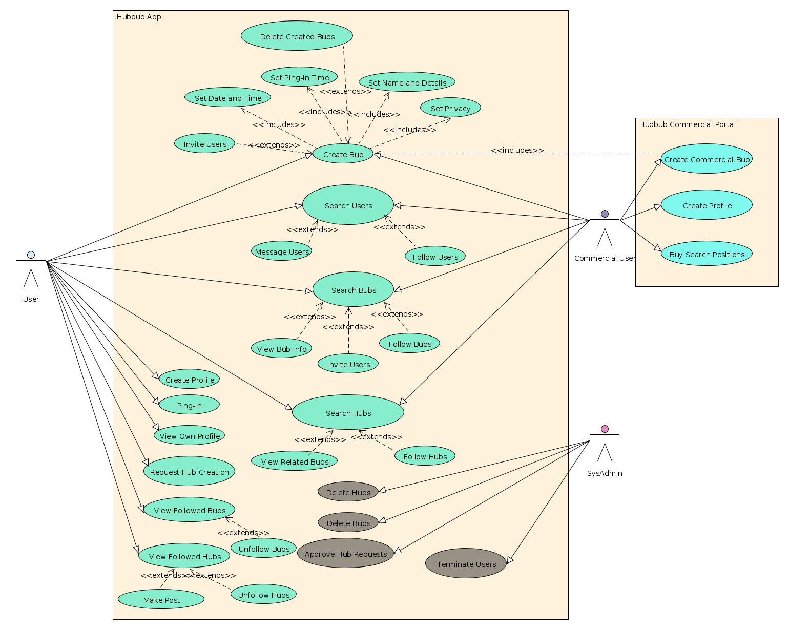

Brief System Overview

The following is a generic example of the application navigation and work flow.

User:
1) A User can create an account with Hubbub inputting important information such as
name, date of birth, email, etc. Alternatively, users can login using other social networking accounts already established.
2) Users can then login and view the main User UI. Lists of Hubs followed (Defaults will be set), Featured or today's Bubs, Followed Bubs, etc.
3) Users at will can create or search for Bubs. When creating, they can invite those followed, set certain times for the event and ping-in, set detail information in regards to the bub, etc.
4) Users at will can search for Hubs. Bubs tagged with the Hub's name will be listed in the Hub's Bub page. Users can follow both the Bub and or the Hub they've searched for respectively.
5) Users at will can search for specific Bubs by Hub tag, name, or time. Users can follow Bub and navigate to the corresponding Hub's tagged within the Bub if wishing to search for similar Bubs in nature or topic.
6) After following Bubs, users will be forced to ping-in at the Bub's respective ping-in times. They will make a decision and their attendance status will be recorded.
7) Users periodically will be information by push notifications of posts in either hubs or bubs they've created or followed.
8) A User session is persistent and can remain running in the background. Refreshing the UI and real-time updating Hub and Bub information will be available as the application is running.
9) However, a user may log out and shutdown the app at any moment. The only persistence afterwards will be the ability and event of a ping-in. Users will be required to ping-in event if the application is not currently in the foreground.

Commercial Users:
1) Commercial Users will have their own login and will have similar abilities to a user with some additional functionality.
2) After creating an account, user privileges will be administered with the addition of creating commercial Bubs. These Bubs will have a verified location and will have the ability to be charged for higher listings when searched under certain tags.
3) Commercial Users can choose certain tags for higher listings and will be charged accordingly for such abilities.
4) After creating events, Commercial Users will then be able to view their events and follow others as well. Navigation through the Hubbub application can occur over the android application and the addition Commercial User options will be accessible at any time.

System Admin:
1) SysAdmin's will be able to login through the app as do regular users. Afterwards, they will have full control over Hub's existence and Bub presentation.
2) At any time, SysAdmin's can modify User existence, Bub existence, and Hub existence if exploitation is to occur.

Use Case Descriptions

The following use cases will be the core of the Hubbub application and will be further explored below:
- Create User
- Create Commercial User
- Create Bub
- Request Hub
- Search Bub
- Search Hub
- Search User
- Ping-In
- Make Post
- View Followed Bubs
- View Followed Hubs
- Invite Users

Create User:
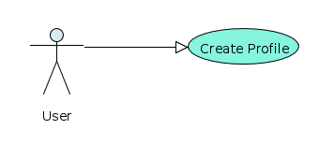

Create Commercial User:
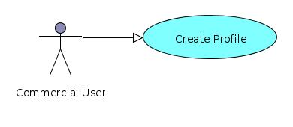

Create Bub:

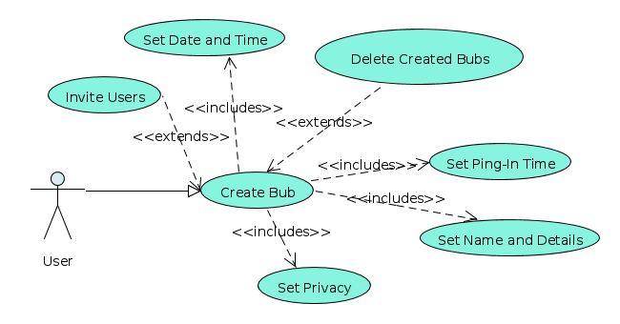

Request Hub:
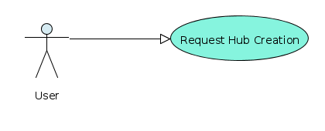

Search Bub:

Search Hub:

Search User:

Ping-In:

Make Post:

View Followed Bubs:

View Followed Hubs:

Invite Users:

